Linux:

- First we have to install the Pax driver in the Linux system. The default Pax driver is ttyS90. Please Check if ttyS90 exists in the dev directory before installation.

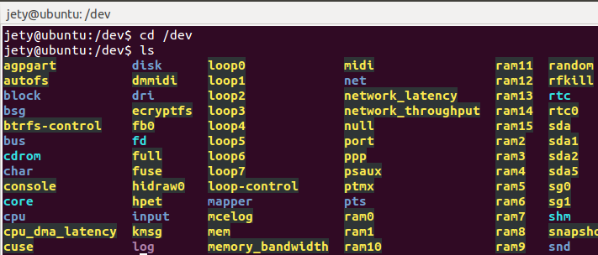

If ttyS90 exists before installation, open pax_ttyPos.c in the driver directory and change DRV_NAME to the port name that is not occupied. For example, changing to ttyS80 changes DRV_NAME to ttyS8. Setting DRV_NAME to ttyS8 means that the driver name is ttyS80, because the latter is self-growth. If two Pax devices are connected, the driver names are ttyS80 and ttyS81.

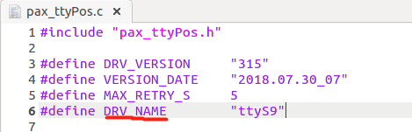

Then go to the driver directory and execute “make install” or “sudo make install”to install the driver. If the ttyS90 appears in the dev directory after the pax machine is connected to the system, the installation is successful.

- JAVA environment
- Ensure that there is a java environment in the system.
- Then copy librxtxSerial.so, librxtxParallel.so to $JAVA_HOME/jre/lib/$(ARCH)/ (eg. $JAVA_HOME/jre/lib/amd64/) .
- Copy RXTXcomm.jar to <JAVA_HOME>\jre\lib\ext or use it to your project lib.

- Open JAVA POSLink with administrator privileges.
sudo java -jar POSLinkJavaDemo.jar
Set the SerialPort of JAVA POSLINK to /dev/ttyS90

Note: Currently, the Linux Driver can only be installed on a 32-bit operating system

